YOUR LOGO HERE

Sample Handbook
2020

Teaching | Service | Research

Program Overview

Purpose
VOLUNTEER PROGRAM NAME primary purpose is to promote the XXXXX through education and support in NAME County, Florida and the surrounding areas.
Add any pertinent program information here. Examples include mission, activities your program conducts, etc.
On the Design tab, you can change the theme, the colors, and the fonts of the document. This will update the entire document to the main color scheme and font scheme that you pick, with the click of a button!
To change any of the images, simply click on them and choose “Change Picture” from the Picture Tool tab. For the image on the first page, double click in the header to access the image and update it as necessary.
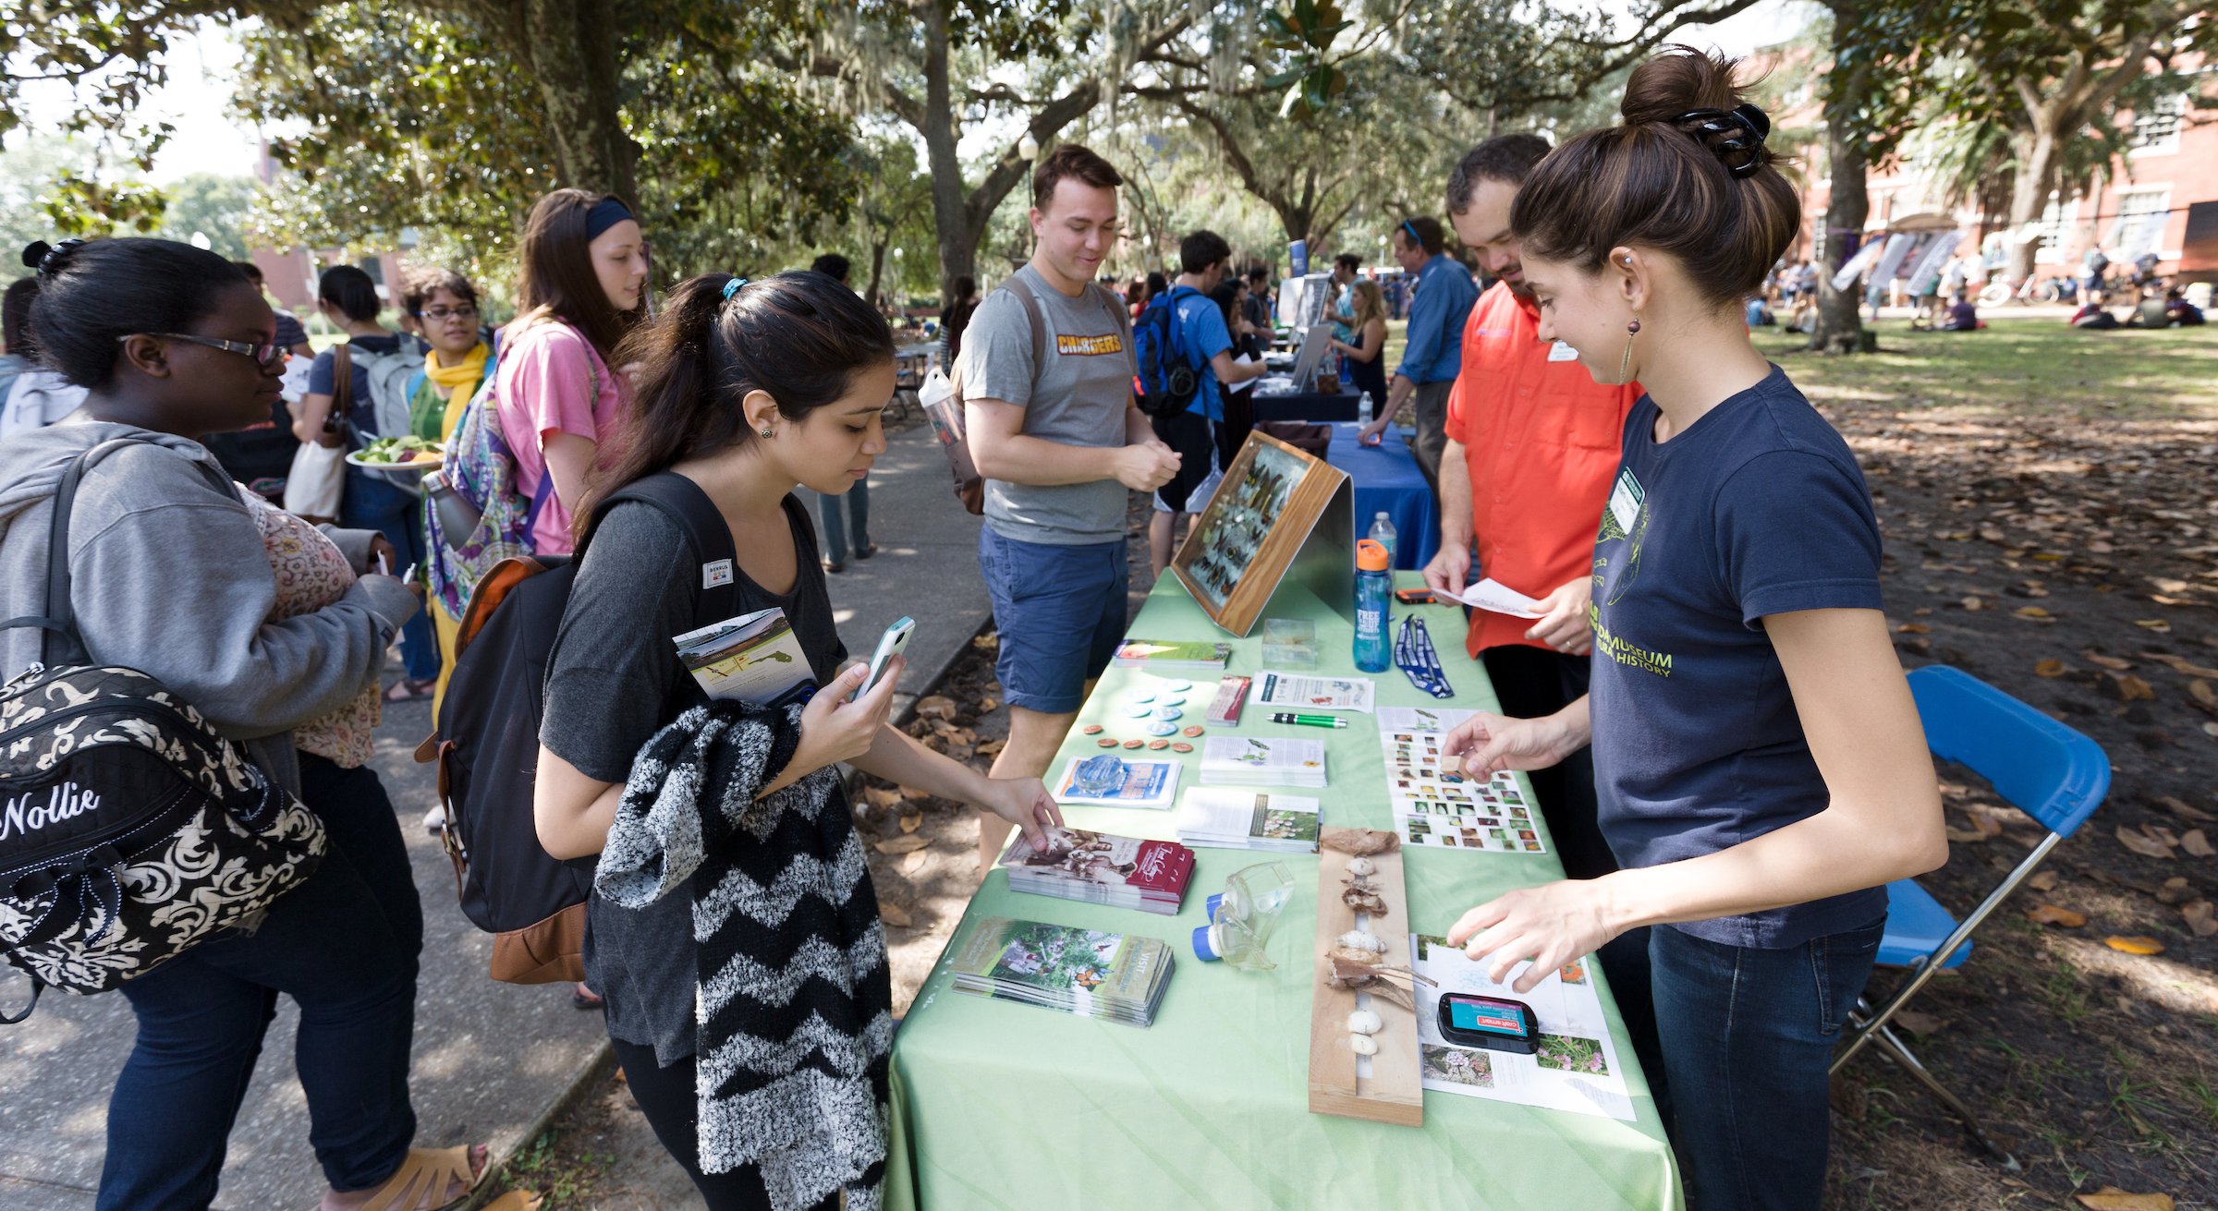
Volunteer Opportunity Descriptions
VOLUNTEER PROGRAM COORDINATOR NAME is the primary contact for the PROGRAM NAME. The volunteer opportunities for this program are made up of a X, Y, Z roles.

Each opportunity has assigned duties and responsibilities; however, some activities are so integral to the administration and direction of growth of the organization, that they shall be overseen by _______.

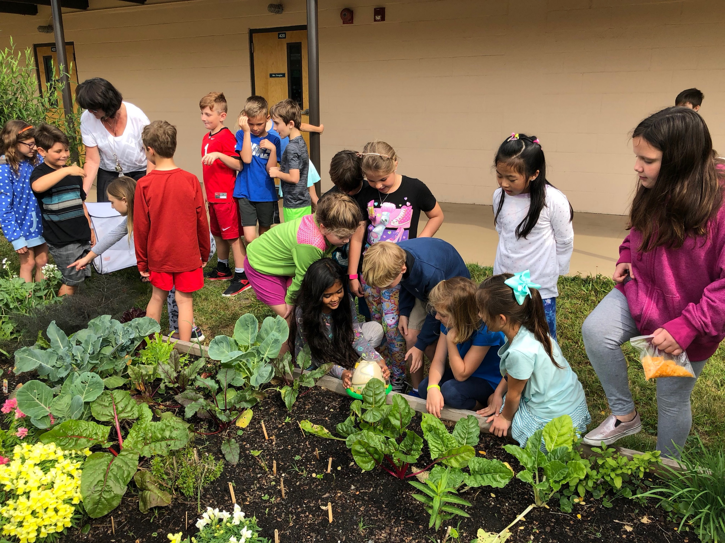
Duties and responsibilities, as well as training requirements for each type of volunteer are outlined in the volunteer opportunity descriptions below.

Volunteer opportunity titles are as follows:

- EXAMPLE
- EXAMPLE
- EXAMPLE

Recruitment & Selection
Recruitment for and selection of volunteers falls to the volunteer coordinator. This person will facilitate the ongoing recruitment volunteers and will work in conjunction with the COLLEGE / DEPARTMENT / ENTITY to promote volunteer recruitment campaigns.
Add any additional information here about the volunteer selection process.

Training & Orientation
Training and orientation will be coordinated by XXXXX. Training materials will be reviewed annually by the XXXXXX. The DEPARTMENT|PROGRAM NAME will approve all trainings, unless otherwise mandated by the University, State, or Federal law. XXXXX will work with the department and university to compile and organize training materials for all levels of volunteers.
Minimum training requirements are located with each volunteer opportunity description. Training must be up to date in order to remain a volunteer of UF.
Add any additional information here about the volunteer training and orientation requirements. Below is a sample format for a training outline.

Sample Training Outline for Babywearing International
This section provides an example of training topics to cover with a new volunteer of Babywearing International.
- About the ORGANZATION/VOLUNTEER PROGRAM (http://babywearinginternational.org/about-bwi/)
- About the volunteer role
- About the program leadership (who to go to with questions/suggestions)
- Volunteer/leaders expectations (Volunteer Code of Conduct)
- Focus on inclusion & respect
  - Welcoming to all visitors/learners
    - Be friendly at meetings, events, on our FB groups and the community. Avoid terms like XXXX. Be sure to use basic terminology. Not everyone understands XXX verbiage.
    - Practice over product, work with what they already own first, if possible. Be welcoming to those who want to spend a little as well as those who want to spend a lot.
- Welcoming to all families/community members who seek our assistance
  - Teaching language, what it is and why it is important.
    - There are many types of families, use inclusive language to help make everyone feel comfortable. (provide examples: i.e. caregiver instead of mom, non-gendered terms, assuming there is a partner)
    - Use person first language to keep the focus on the person/individual.
  - Listen carefully to the individual's needs and do not make assumptions about their needs based on their size.
  - Be respectful of participant choices and do your part to create a warm and welcoming community.
- Etiquette as a Volunteer
  - Arrive at the time you said you would - half an hour early for set up shift/15mins early for regular shift.
  - Let a leader know if you are not going to make it to the meeting after all.
  - Things happen, we know, but try to give us as much notice as you can.
- Once at a location remember to be respectful, kind and welcoming, especially to new attendees
- This is not the time to gossip/speak negatively; think about how what you are saying will be taken from someone not involved in the situation and is there looking for support.
- Be respectful of personal boundaries of other leaders and members.
  - Don't touch someone’s personal belonging without first getting permission – even to relocated belongings
- Assist at the beginning by signing people in.
- Keep chatter to a minimum during introduction so members can hear important info.
- Stay in the area you are scheduled for the duration of the session
- Clean up your area before leaving it.
- Safety Basics

Forms, Applications, and Agreements
In this section, you may insert any forms or necessary documents that volunteers should have or complete.

Volunteer Interest Form

Volunteer Agreement

Volunteer Application

Volunteer Emergency Contact Information

Volunteer Service Expiration
Volunteer service expires annually, 365 days from service start date. Annual approval of volunteer services is required for each volunteer regardless of history or years of service. The department or academic unit may release a volunteer at any time, for any reason and without prior notice.

