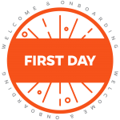
First-Day Checklist and Itinerary
Best Practices for Direct Supervisors when Onboarding New Employees
Onboarding assists organizations in ensuring that new employees are up and functioning
as soon as possible. If the onboarding process is implemented properly, it will enhance new employees’ transitions into the organization and help them become more engaged. – Workforce Management, 2009a
Practice | Tasks
Enthusiastically WELCOME the new employee | Prepare work area with a clean desk and chair, stock the necessary supplies, remove non-essential items and organize the space
 | Set up computer with software and all needed components
 | Set up phone including their name
 | Have a name plate available for their office area
 | Email or provide a copy of the TEAMS/USPS Employee Handbook
Show that you are prepared for them | Schedule orientation meetings with appropriate team members and staff
 | Prepare a detailed onboarding plan
 | Have email account ready
 | Provide a welcome card or small gift
 | Be sure to have your new employee get a Gator 1 ID card
Connect the new employee to team members, HR rep, and his/her buddy | Review the Buddy System Process
 | Select and notify a buddy
 | Arrange a meet with the buddy
 | Arrange a meeting with the HR rep for new employee conversations
 | Schedule one-on-one “Meet the Team” meetings
 | Review the department’s organizational chart
 | Explain each team member’s role and responsibilities (who serves as lead, who is the “go-to” person for different questions, etc.)
 | Give a tour of building, lunch area, restrooms (supervisor or buddy)
 | Have lunch together with supervisor and/or buddy
Direct supervisor explains the expectations and onboarding plan | Meet with the new hire to discuss job description, expectations, policies, and walk through the TEAMS/USPS Employee Handbook
 | Provide opportunities for questions about the expectations
 | Review onboarding plan
 | Set milestones and specific deadlines for the first week
 | Provide time to explore benefits using UFHR’s Benefits website and show how to make an appointment with a benefits specialist
Onboarding is the process of integrating and acculturating new employees into the organization
and providing them with tools, resources and knowledge to become successful and productive.
– Getting On Board, A Model for Integrating and Engaging New Employees, Partnership for Public Service, 2008

First-Day Sample Itinerary
8:00-9:00 a.m.
Meet with the direct supervisor (provide a room #)
- Building tour (could tour with their buddy)
  - Work areas and additional rooms to use
  - Workstation and email log-in
  - Copier/FAX/scanner review
  - Library, supply closet, supply requests and other workspaces
  - Service drive pass (if applicable)
  - Bathroom, employee lounge, mailroom
  - Refrigerator, microwave, water and coffee
- Policies (supervisor)
  - Establish hours, including lunch and attendance expectations.
  - Email policy
  - Telephone usage (how-to and logging long distance)
  - Professional dress and conduct
- Miscellaneous
  - Department and HR policies
  - Discuss meetings:
    - Weekly check-in with direct supervisor (date and time)
    - Biweekly team meetings (date and time)
    - Monthly all-employee department meetings (date and time)
  - Cubicle/office name plate and UF name tag
9:00-10:00 a.m.
Meet with HR rep (Dean’s/VP’s Office)
- If the hiring process is not completely finished, complete the final paperwork with (HR rep name).
The employee may need:
  - Copy of driver’s license and SSN card
  - To complete loyalty oath form
- GatorLink log-in and password for computer and email access (36-hours after the UFID is created)
- Provide phone access and password information
- Security to the building (mention any special security for your area), keys and parking tips
10:00 a.m. to 12:00 p.m.
- Order your parking decal online from Transportation and Parking. Make sure to tell your new employee which decal they need to park in your area or for any on campus traveling their job may require. For any employees that need special accommodations for parking can visit this webpage.
- Faculty and Staff are to work with their department’s ID Card Authorizer to place a request for a Gator 1 Card. Set up your employee with the person responsible for this in your department.
- Get settled into your workspace.
- You’ll have meetings with all of your teammates over the next two weeks, so check out their bios. (include hyperlink)

12:00-1:30 p.m.
Have lunch with direct supervisor and/or your buddy.
1:30-4:00 p.m.
Orientation to the calendar, HR website and myTraining
- Get your calendar ready for unit business. Share full calendar details and request full
calendar details for all members of unit. Please include: (List with name and address)
- Become familiar with how to enter time and/or leave in myUFL.
- Explore your benefits using UFHR’s Benefits website and show them how to make an appointment with a benefits specialist
- Review the unit’s website and the HR website including the “Toolkit Resource Center.”
- Tour the myTraining system:
  - Log in to myUFL > Main Menu > My Self Service > Training and Development > myTraining or http://mytraining.hr.ufl.edu.
  - Take the myTraining system tour
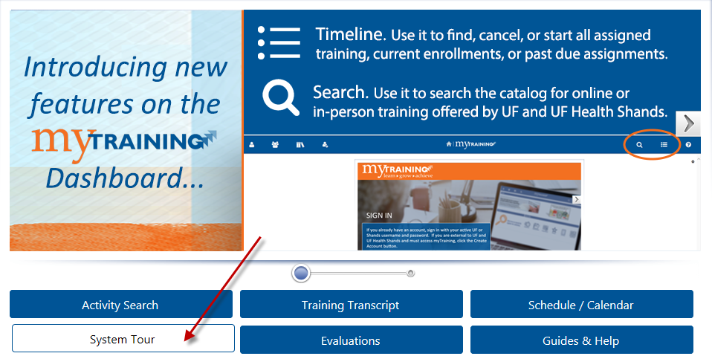
  - Start one of the required trainings

4:00-5:00 p.m.
Meet with supervisor
- Review job duties, discuss first project and upcoming projects.
- Discuss the TEAMS/USPS Employee Handbook and ask questions.
- Set goals for the first week with specific deadlines.
- Discuss quality work expectations.

