Attaching Documents to the POI-Volunteer ePAF
Contents
Attaching Documents to the POI-Volunteer ePAF 1
Navigation 1
In the Person of Interest Section 1
For Assistance with the Volunteer Tracking System 2

In cases where you have volunteers who are minors, you must upload the Parental Approval and Authorization to Treat Minors Form for each minor volunteer. You may do this via a Person of Interest ePAF in myUFL. To do so, follow the steps outlined in the Adding a New Volunteer When the Volunteer’s UFID is Known instruction guide or the Adding a Volunteer When the Volunteer Does Not Have a UFID instruction guide, then follow the steps below.

Navigation
myUFL: my.ufl.edu > Main Menu > Human Resources > UF Departmental Administration > ePAF Homepage

In the Person of Interest Section
- Click the Documents button to upload this form.
- A new tab for OnBase (UF’s document management system) will open.
  - You will not lose your place in myUFL.
- Click the Blue Arrow (upload icon).
- Click the Choose File button and locate the appropriate Parental approval and Authorization to Treat Minors form.
- Click the Import button.
- You will see a notification stating “Imported Successfully” at the top of the page.
- Click the Exit button to the right to return to myUFL.
- On the pop-up, click the Yes button.
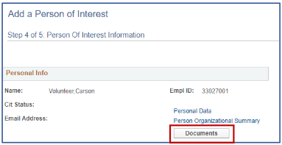
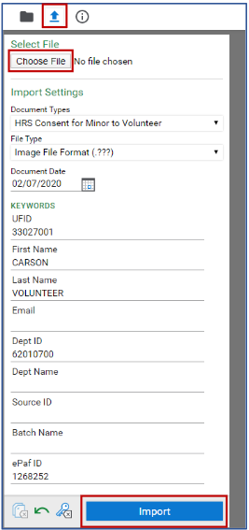

For Assistance with the Volunteer Tracking System
Contact volunteer@hr.ufl.edu.

