User Guide: Foreign National Information System (FNIS)



Guide to FNIS

FNIS is a secure website used to collect and maintain data to determine your nonresident alien vs. resident alien status for tax purposes and whether you are eligible for any tax benefits.

All foreign nationals receiving funding from University of Florida, such as salary, hourly wages, stipends, fellowships, and assistantships, must complete FNIS.

Please note that UF Payroll Services is not permitted to provide personal tax advice. For questions of this nature, we recommend consulting a tax advisor or tax preparer outside the university or contacting the IRS for guidance specific to your situation.

Steps you will complete

- Log into your FNIS record with the FNIS login credentials provided in the ‘University of Florida: Access for FNIS System’ email.
- Change password and consent to receive tax documents electronically in FNIS.
- Complete all pages and required fields in the Data Entry section of your FNIS record.
- Please contact us or call 352-392-1231 if you have any FNIS-related questions.

STEP 1: Log into FNIS
- Your FNIS login credentials will be delivered via ‘University of Florida: Access for FNIS System’ email.

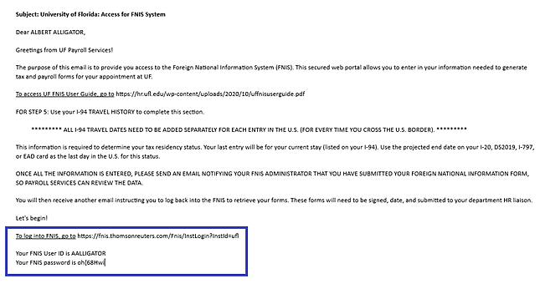

- You will be prompted to change your password.
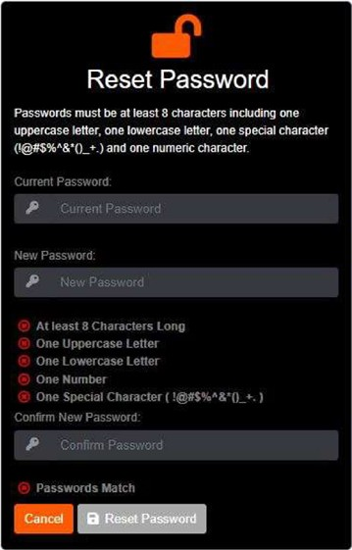

- If you can’t access your account and need to reset your password, click ‘Can’t access your account?’

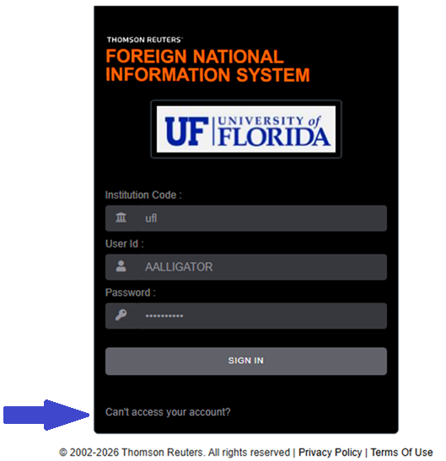

STEP 2: Consent to receive electronic documents

After logging in, navigate to IRS Forms and select "Consent":
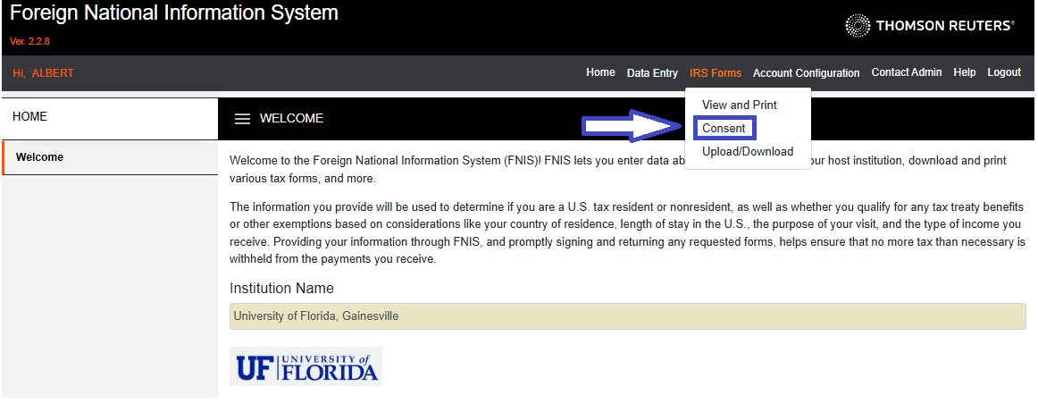

Review the Description of Services and give consent to UF to deliver your forms electronically. You must consent to both form types to receive forms electronically.

- Consenting to electronic delivery ensures you are receiving your tax documents as quickly as possible.
- And importantly, if you do not provide consent, UF will not be able to electronically deliver any FNIS tax or treaty documents to you.

STEP 3: Data Entry

Navigate to Data Entry located in the top menu bar and complete the first six pages in this section.

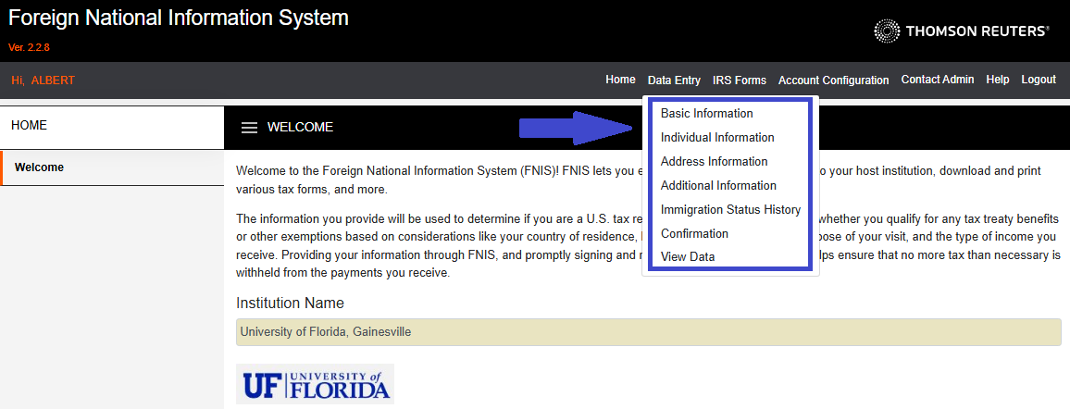

Click the Edit button to enter your data

The Edit button is located at the bottom of each page and in the top-right corner. You must click Edit to make changes on each page.

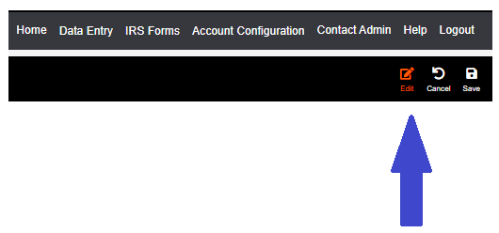

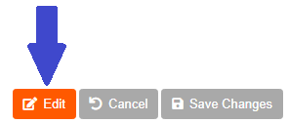

Save your changes on every page

The Save Changes button is located at the bottom of each page and in the top-right corner. Be sure to save your changes on each page to retain your work. If you do not, any data entered on that page will be lost.

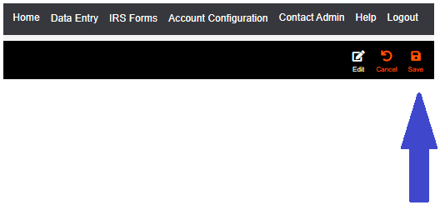

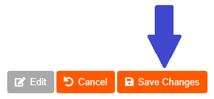

Data Entry: Basic Information

Navigate to the "Basic Information" page located under Data Entry:

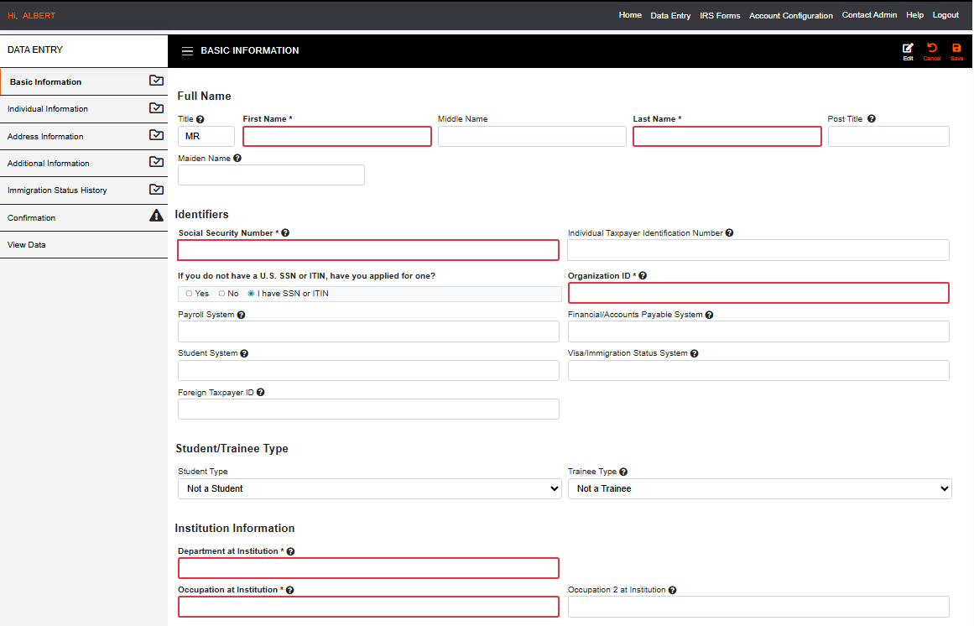

Data Entry: Basic Information

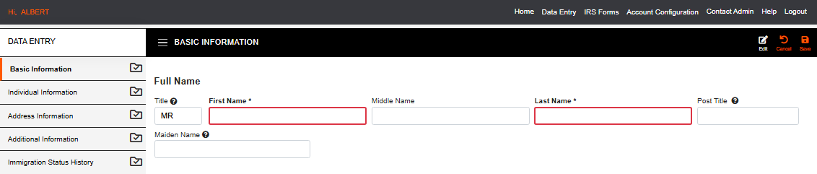

Full Name: Verify that your name matches how it appears on your Social Security card. If it does not match, please correct it in FNIS.

If you do not have a Social Security card yet: Verify that your name matches how it appears on your passport. If it does not match, please correct it in FNIS.

Data Entry: Basic Information

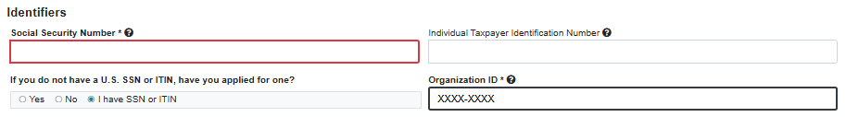

- Enter your U.S.-issued Social Security Number (SSN) and verify your UFID (Organization ID)

If you do not have an SSN, you can save this page without a number in this field. Select “No” for the FNIS question “If you do not have a U.S. SSN or ITIN, have you applied for one?” Then continue completing your FNIS record.

You will see a pop-up message alerting you to the empty fields, but you can save the page anyway:

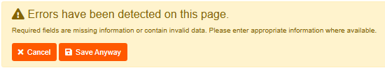

You will be able to submit your FNIS record without an SSN.

Data Entry: Basic Information

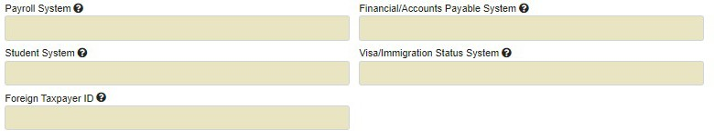


- Foreign Taxpayer ID: You may enter a Foreign Taxpayer ID if you have one, but this field is NOT REQUIRED. This ID is usually issued by your home country.
- You cannot enter any information in any other fields in the Identifiers section of this page. These fields are not necessary for UF payroll processing.

Data Entry: Basic Information
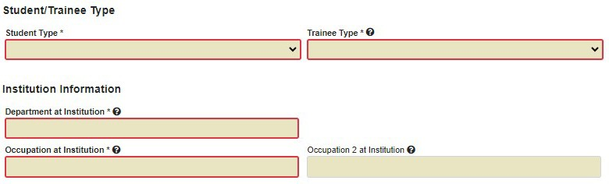

- Student Type: Choose the option that applies to you.
- Trainee Type: Choose the option that applies to you.
  - For F and J visa holders, choose "Not a Trainee." This field is tied to your primary reason for being in the U.S. on your F/J visa, which is not training, even when doing CPT or OPT.
- Department at Institution: DO NOT enter "University of Florida." Enter the name of the department that hired you.
- Occupation at Institution: Enter your job/position title.
- Occupation 2 at Institution: Leave this field blank, even if you have more than one position.

Data Entry: Individual Information

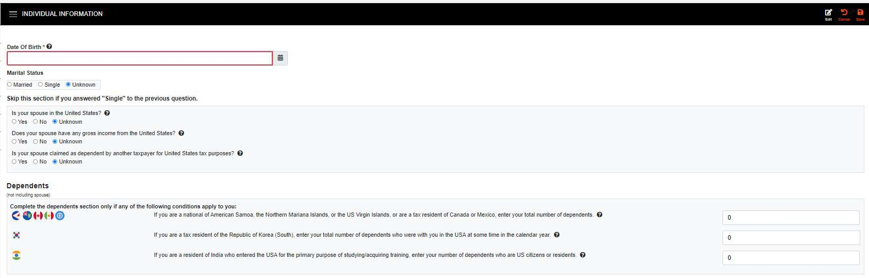
- Date of Birth: Verify that your date of birth is correct; if incorrect, please update it.
- Marital Status: Enter the data that applies to you.
  - If you are single, skip the three spouse questions in the box below Marital Status. If you are married, answer all three spouse questions.
- Dependents: Enter any data that applies to you. If you have no dependents, leave these fields blank.

Data Entry: Individual Information

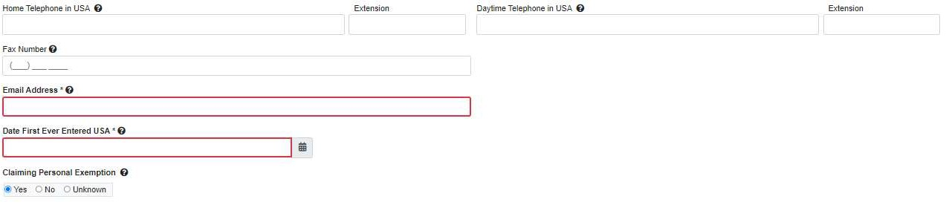
- Phone numbers: Enter any phone information you want to provide in your FNIS record.
- Email Address: Enter the email address you want to use for your FNIS communications
- Date First Ever Entered USA: Enter the first date you ever entered the U.S. This must be the date you first entered the U.S. for any reason, regardless of date or status.
- Claiming Personal Exemption: Nonresident Aliens (NRAs) cannot claim personal exemption deductions for themselves, spouses, or dependents.

For more detailed information, click the question mark icon next to each question. If you need additional guidance, please consult a tax professional. UF Payroll Services is not permitted to provide personal tax advice.

Data Entry: Address Information

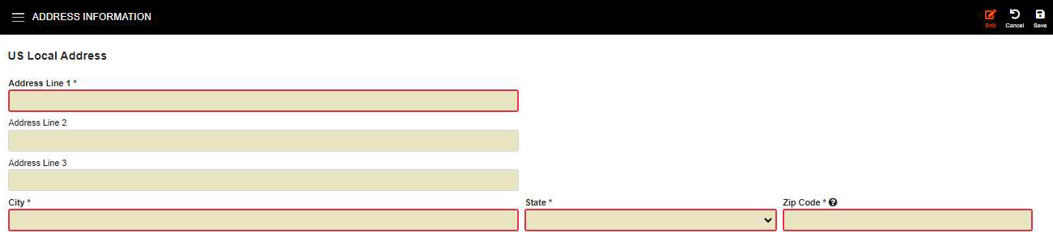
- Address Line 1: Enter your building number and street name, for example 3800 SW Williston Rd.
- Address Line 2: Enter your apartment number if applicable, for example Apt 43.
- Address Line 3: Line three is usually not applicable, so skip this line unless your U.S. address requires additional information.
- City: Enter your U.S. local city.
- State: Enter your U.S. local state.
- Zip Code: Enter your U.S. local zip code.

Data Entry: Address Information
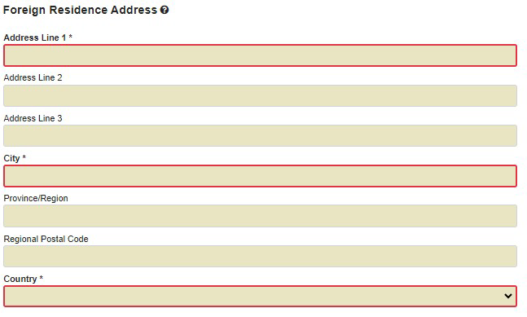

- Foreign Residence Address: Enter your foreign residence address and complete all required fields.

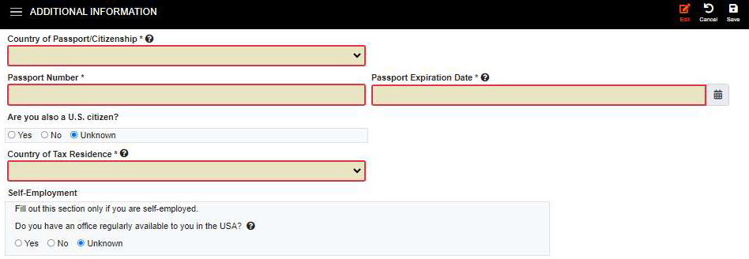
Data Entry: Additional Information

- Country of Passport/ Citizenship: Enter your country of citizenship.
- Passport Number: Enter your passport number.
- Passport Expiration Date: Enter your passport expiration date.
- Are you also a U.S. citizen?: Choose an answer for this question. If you are a U.S. citizen or a U.S. permanent resident, please stop entering information into FNIS and notify us.
- Country of Tax Residence: Choose your country of tax residence, which is the country in which you were (or would have been) a tax resident before coming to the U.S. for your current program. The U.S. is not an option, even if you are a resident alien for U.S. tax purposes.
  - This country will be listed on Form 1042-S, which may apply to you when Payroll Services analyzes your FNIS record details.
- Self-Employment: Complete this section only if you are self-employed.

Data Entry: Additional Information
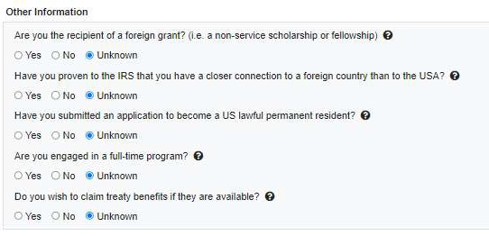
- Other Information: Complete this section as it applies to you.
  - "Have you proven to the IRS that you have a closer connection to a foreign county than to the USA?": Only choose "Yes" if you have gone through the very lengthy process to establish this connection.
  - "Do you wish to claim treaty benefits if they are available?": If you want to claim treaty benefits (even if you don't know if you qualify), please choose "Yes" or "Unknown." Choosing "No" will deny treaty benefits automatically.

For more detailed information, click the question mark icon next to each question. If you need additional guidance, please consult a tax professional. UF Payroll Services is not permitted to provide personal tax advice.

Data Entry: Immigration Status History
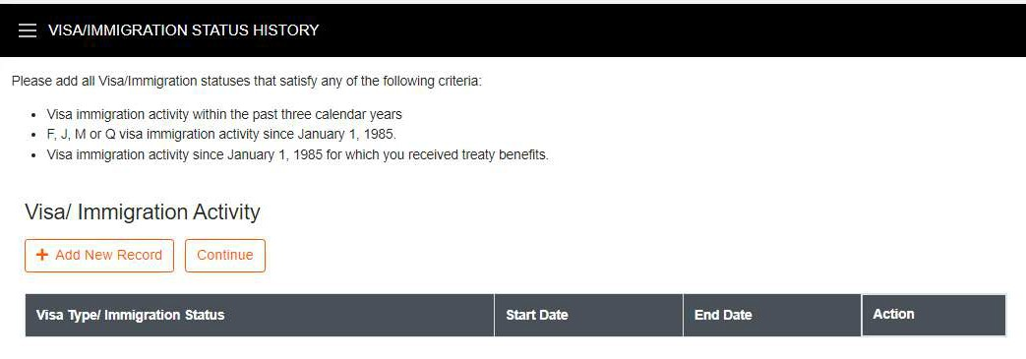

On this page, you will enter information about your immigration history in the U.S.
You should record ALL YOUR U.S. ENTRY AND EXIT DATES, as well as status change dates that occurred in the U.S.
Because the information you list here documents your physical presence in the U.S., you should create individual records for each visit instead of summarized rows that include days you were not in the U.S.
This level of detail is important because the amount of time you have been physically present in the U.S. can impact your eligibility for tax treaty benefits, as well as your tax residency status.

Data Entry: Immigration Status History
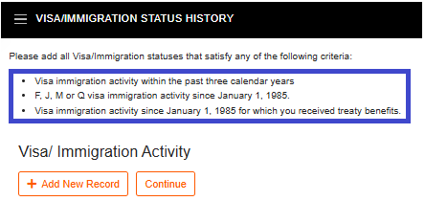

You should enter all travel information that satisfies any of the three criteria on page 5:
- F, J, M or Q visa immigration activity since January 1, 1985.
  - For example: If you were in the U.S. on an F visa at any point after January 1, 1985, that travel instance should be included on page 5.
- Visa immigration activity since January 1, 1985 for which you received treaty benefits.
  - For example: If you were in the U.S. on any type of visa and received a treaty benefit since January 1, 1985, that travel instance should be included on page 5.
- Visa immigration activity within the past three calendar years.
  - For example: If you have traveled to the U.S. as a tourist within the past three calendar years, that travel instance should be listed on page 5.

Data Entry: Immigration Status History

- Your current status must be listed on this page.

- When adding travel dates, be sure to use your actual U.S. entry/exit dates, not the validity dates shown on your visa.

  - If you don't have exact dates for a travel instance, please use your best estimate, or refer to your travel history on the U.S. Customs and Border Protection (CBP) website: https://i94.cbp.dhs.gov/home From this site, go to the "View Travel History" tab to obtain this information.

- Activity start and end dates cannot overlap between different records. An error message will pop up if you have any overlapping dates.

Data Entry: Immigration Status History

To add an immigration activity, click the 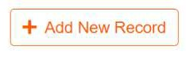 button and the screen below will appear.

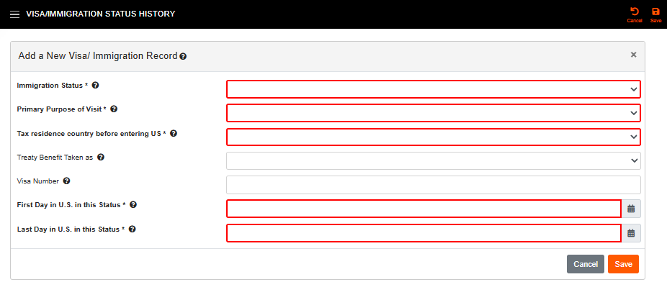
Add information for each travel instance. Remember that you can click on the question mark  for more detailed information about any question.

Data Entry: Immigration Status History

- Immigration Status: Choose the status that applies to your activity, such as F-1 Student, J-1 Exchange Visitor, or H-1B Worker in Specialty Occupation. You may have a different status, so choose the status that applies to your activity.
  - If your activity was tourism or business, select the appropriate tourism or business option. The most common statuses include:

    - B-1 Visitor for Business
    - B-2 Visitor for Pleasure
    - VWB Business – ESTA for Business
    - VWT Tourist – ESTA for Pleasure
    - WB-1 Canadian Walkover for Business
    - WB-2 Canadian Walkover for Pleasure

Data Entry: Immigration Status History

If you DID NOT select a J status, go to the next page in this guide.
If you DID select a J status, the J Subcategory field will appear:

J Subcategory: Choose the subcategory that best aligns with your Exchange Visitor Category on your DS-2019.

Data Entry: Immigration Status History

Primary Purpose of Visit: Choose the purpose that best describes your activity. The most common purposes are:

F Status | J Status | H Status | B or VW Status
Studying in Degree Program | Studying in Degree Program | Temporary Employment | Tourist Activities
Studying in Non-Degree Program | Studying in Non-Degree Program | Conducting Research | Business Activities
Practical Training/J-1, F-1 (OPT/CPT) | Conducting Research | Lecturing | In Transit
 | Clinical Activities |  | Summer Travel / Work
 | Teaching
 | Lecturing

Other purposes may apply to your status. Please choose the one that best fits your activity.

- Tax residence country before entering the U.S.: Choose your country of tax residence, which is the country in which you were (or would have been) a tax resident before coming to the U.S. for your current program. The U.S. is not an option, even if you are a resident alien for U.S. tax purposes.
  - This country will be listed on Form 1042-S, which may apply to you when Payroll Services analyzes your FNIS record details.

Data Entry: Immigration Status History

For OPT, enter the status as a separate record.

Immigration status will be F-1 with the Primary Purpose of the visit as ‘practical training’.

For both the start and end dates, use the dates listed on your EAD card ('Valid From' and 'Card Expires').

For your F-1 student record (prior to OPT), the start date should be your actual arrival date in the U.S., and the end date should be the day before the 'Valid From' date on your EAD card.

Data Entry: Immigration Status History
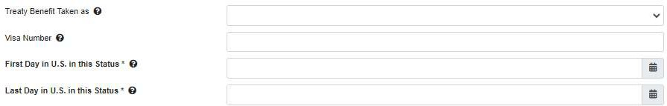

- Treaty Benefit Taken as: This field is not required and can be left blank. If you enter data here, the only acceptable answer is "Unknown."
- Visa Number: If you have a visa, enter the visa number associated with this travel instance.
- First Day in the U.S. in this Status: This should be the date you entered the U.S. in this status, which may be the date on your most recent arrival record, Form 1-94.
  - If you were already in the U.S. for a status change, use the date of the status change.
  - Do not use the validity dates on the visa page in your passport.
- Last Day in the U.S. in this Status: This is one of three possible dates:
  - An exit date from the U.S.,
  - The end date of a status before beginning a new status while in the U.S., or
  - The program end date on your status document. Please note that the last end date
listed on page 5 should be the end date of your current status.

Data Entry: Immigration Status History
- If you DID select an F or J status, the SEVIS ID field will appear:

SEVIS ID: This field is not required and can be left blank. If you enter data here, use the SEVIS ID that appears at the top of your status document.
- If you DID select a tourism or business status, the Honorarium fields will appear:
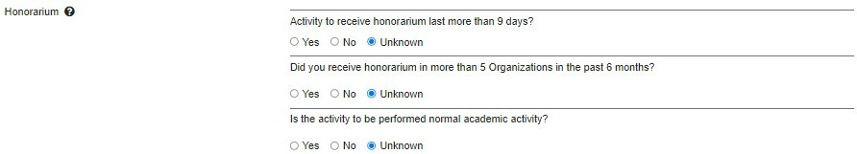
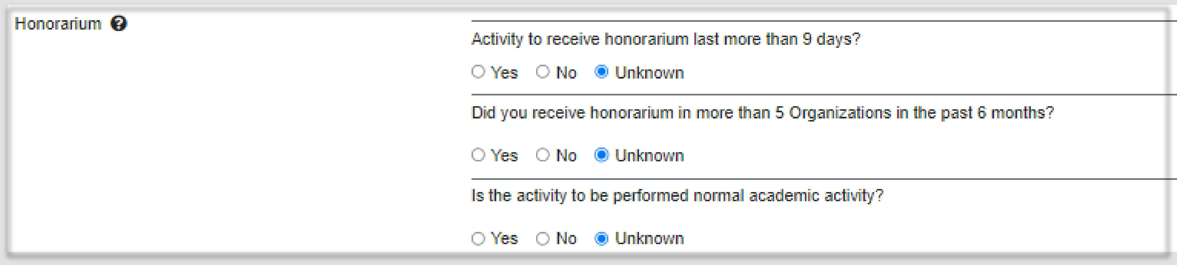

Honorarium: These fields are not required and can be left "Unknown." If you enter data here, choose the answers that best apply to your situation.

Data Entry: Confirmation

On the "Confirmation" page, you will confirm that all the information you have submitted is accurate.
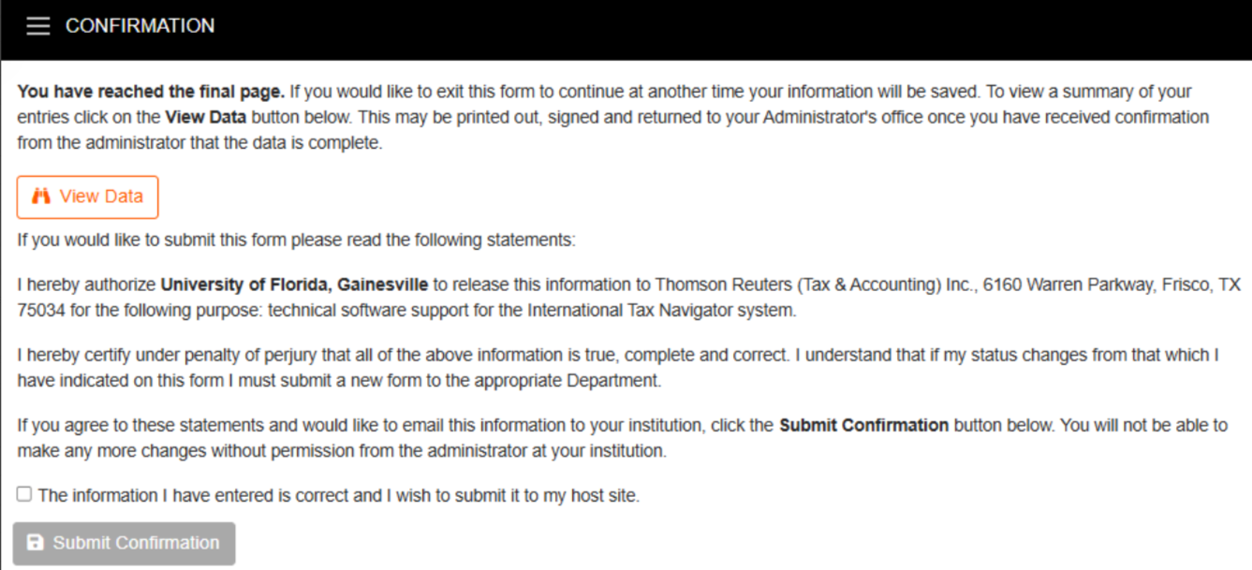
Once you click the Submit Confirmation button, your edit access is disabled and your FNIS record will undergo administrative review.

If you need to edit your record, you must contact us or call 352-392-1231 for assistance.

Data Entry: View Data

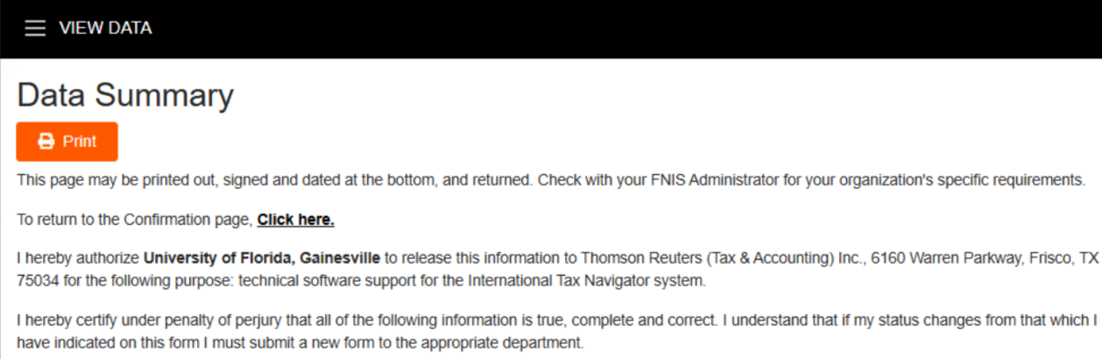
Last, you can view your Data Summary on the "View Data" page:

ONCE ALL INFORMATION HAS BEEN ENTERED AND SUBMITTED, PLEASE EMAIL YOUR FNIS ADMINISTRATOR TO CONFIRM THAT YOU HAVE SUBMITTED YOUR FOREIGN NATIONAL INFORMATION FORM SO PAYROLL SERVICES CAN REVIEW YOUR DATA.

Please contact us or call 352-392-1231 if you have any FNIS-related questions.

