FORM I-9 & E-VERIFY UF GUIDELINES

GUIDELINES FOR IMMIGRATION COMPLIANCE
UFHR - EMPLOYMENT OPERATIONS & RECORDS
ufhr-employment@ufl.edu

Table of Contents
Form I-9 Overview 1
Form I-9 Sections 1
- Section 1 2
- Section 2 2
Remote Hires 3
- Virtual Inspection Procedure 3
- Authorized Representative Inspection Procedure 3
List of Acceptable Documents 4
- Overview 4
- List A 5
- List B 6
- List C 6
Foreign Nationals 7
- Common Documents 7
Reverifications 11
- Process and Guidelines 11
- Steps to Reverify 11
- Key Reminders 11
- Reverification is Not Required For 12
- Reverification is Required For 12
E-Verify 15
- Overview 15
- Process 15
- E-Verify Case Statuses 15
- Steps to Prevent Error-Request Help 15
- UF Temporary IDs 16
- Pending Referral Cases 16
Contacts & Resources 17

FORM I-9 OVERVIEW
As required by federal law, the University of Florida (UF) must complete Form I-9 for certain individuals hired for employment in the United States. The purpose of Form I-9 is to verify that employees are eligible to work in the United States, as required by federal law.

Currently, all UF employees complete Form I-9 through GatorStart, UF’s electronic onboarding system. Employers may only require an employee to complete Form I-9 after an offer has been made and accepted. Requiring an employee to complete the form before acceptance is unlawful and considered discriminatory by the U.S. Citizenship and Immigration Services (USCIS).

Who Should Complete Form I-9?
Form I-9 is required for:
- Any individual receiving salary or wages from UF.
- Individuals participating in clinical trials.
- Employees receiving additional payments from UF.

Who is Exempt from Form I-9?
Form I-9 is not required for:
- Employees that are hired on or before Nov. 6, 1986.
- Individuals who do not physically work on U.S. soil.
- Unpaid appointments such as Courtesy Faculty, Fellowships, and ISCR.
- Employees providing labor through contract services (e.g., temporary agencies).

FORM I-9 SECTIONS
The USCIS Employer Handbook serves as a guide for HR administrators handling Form I-9 and E-Verify. This guide includes instructions on how to complete each section of the Form I-9, deadlines, retention rules, and examples of completed forms, how to correct errors, and acceptable documents employees can provide.
A few of these resources are provided by these quick shortcuts: Section 1 | Section 2 | Reverification | Acceptable Documents
Form I-9 is a one-page form comprising two sections. Each section contains different requirements, and failure to comply could result in delayed hiring, transmission of incorrect data to USCIS for E-Verify purposes, and civil penalties.

Section 1
- Must be completed by the employee on or before the first day of employment.

*Example:
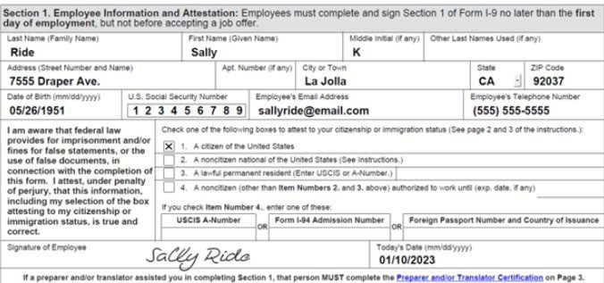

Section 2
- Must be completed by an authorized university representative within three business days of the employee’s start date.
*Example:
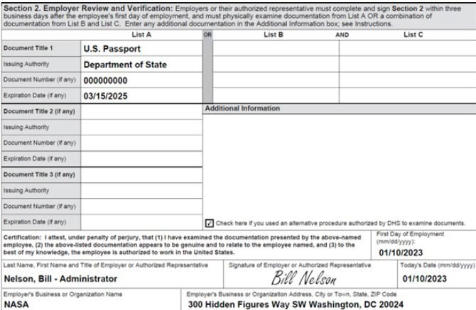

*Note: the way Section 1 & 2 is completed above only represents one scenario; hiring scenarios will vary based on individual circumstances.


REMOTE HIRES
Whether a new hire will be working completely remote, have a hybrid schedule, or needs to complete Section 2 before they relocate to their new hiring site, there are two inspection procedures that may be used to complete Section 2 from afar while staying compliant with federal guidelines.

Virtual Inspection Procedure
If you use the alternative procedure at an E-Verify hiring site, you must apply it consistently to all employees there. However, you can choose to use it only for remote hires while requiring in-person document review for onsite and hybrid employees, as long as this practice is not discriminatory based on citizenship, immigration status, or national origin.
- Employee provides copies (front and back, if the document is two-sided) of I-9 documents or an Acceptable Receipt
- Employer examines copies of I-9 documents or an acceptable receipt to ensure that the documentation presented reasonably appears to be genuine and relates to the employee
- Employer conducts a live video interaction with the individual presenting the document(s) to ensure that the documentation reasonably appears to be genuine and relates to the individual
- The employee must first transmit a copy of the document(s) to the employer (per Step 1 above) and then present the same document(s) during the live video interaction
- Employer retains a clear and legible copy of the documentation (front and back if the documentation is two-sided)
- Employer indicates that the Alternative Procedure was used when completing Section 2 in I-9 Management
  - On the I-9 (version 08/01/2023) check the box to indicate that you used an alternative procedure in the Additional Information field in Section 2
Example of virtual attestation box in I-9 Management:
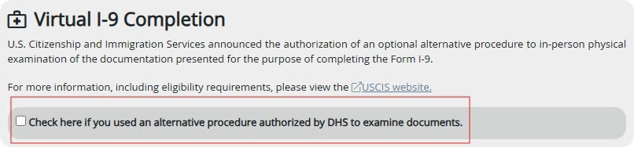

Authorized Representative Inspection Procedure
For employees without access to a UF facility:
- Employee locates an HR professional for assistance.
  - To locate someone near their area, please contact Employment Operations & Records with the zip code of the location the employee is at and EOR will

provide a list of contacts.
- Employee completes Section 1 of Form I-9 on or before their first day.
- Authorized representative reviews and completes Section 2 within three business days.
  - In certification area of Section 2, “First Day of Employment” must match start date (note: if start date is unknown, it may be left blank but must be filled in at a later time)
  - Business name: University of Florida
  - Business address: 903 West University Ave., Gainesville, Florida 32601
  - Note: if authorized representative is a notary, the notary should not affix their seal to Form I-9
- The original I-9 and supporting documents are sent to UF Hiring manager/HR representative.
- The representative completes and submits E-Verify case in I-9 Management
  - Upload supporting documentation to OnBase to confirm the authorized representative completed and verified to the E-Verify case

LIST OF ACCEPTABLE DOCUMENTS
Employees must provide documentation to their employers to show their identity and authorization to work in the United States. It is important to note that the examples provided in the subsequent pages below for List A, B, and C. are only common examples but are not all of the acceptable documents. For a more complete list please visit Form I-9 Acceptable Documents.

Overview
- Employers cannot specify which documents an employee should provide.
- When completing Section 2, authorized representatives must review original documents, not photocopies.
- Expired documents or restricted work authorization documents (e.g., Social Security cards marked "Valid for Work Only with DHS Authorization", etc.) cannot be accepted.
- I-9 documents cannot be emailed due to security concerns.

List A Documents
Documents that establish both identity and employment authorization. Employees presenting an acceptable List A document should not be asked to present any other document for I-9 purposes.

U.S. Passport/Passport Card Examples:
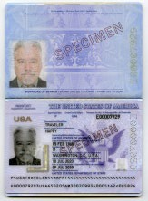
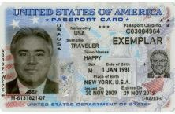

Permanent Resident Card/Alien Registration Receipt Card (Green Card) Examples:
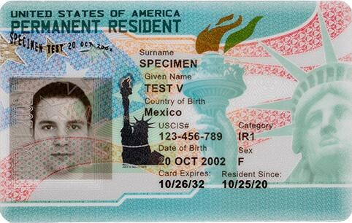
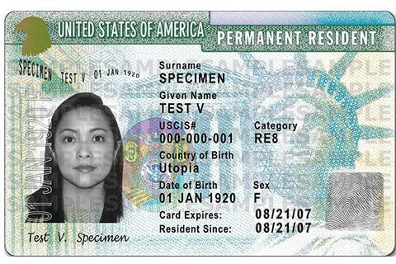

List B Documents
The documents on List B establish only identity. Employees who choose to present a List B document must also present a document from List C for Section 2. Sample identification includes but are not limited to driver’s licenses, state identification cards, military and school IDs, etc.
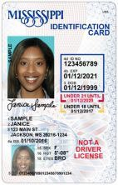
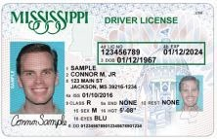
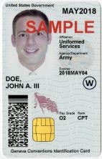

List C Documents
Documents that establish employment authorization. Employees who choose to present a List C document must also provide a document from List B, to reflect proof of identity for Section 2. Samples documents that reflect employment authorization include but are not limited to unrestricted social security cards, birth certificates, etc.
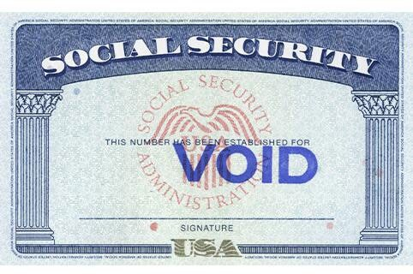
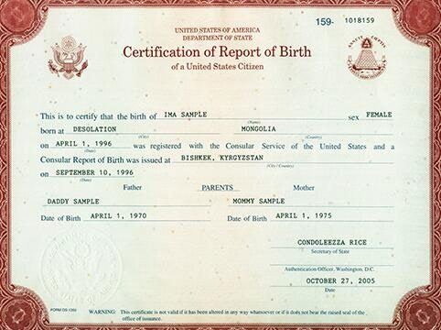

Foreign Nationals

Common Documents
The process for hiring a Foreign National Employee is different from hiring a U.S. citizen and permanent resident. The process may include obtaining employment authorization before the individual can work in the U.S. or, in some instances, the foreign national may already have employment authorization that can be used for a position at the University of Florida.
The following documents below are common examples:
U.S. Visa
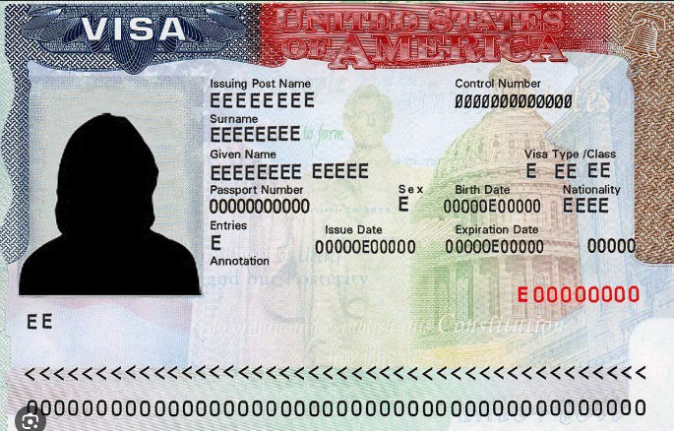

Foreign Passport
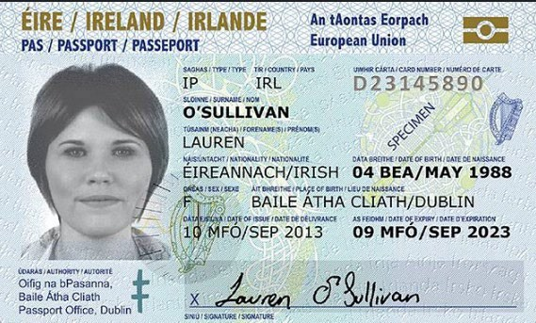

I-94 Form Arrival/Departure Record
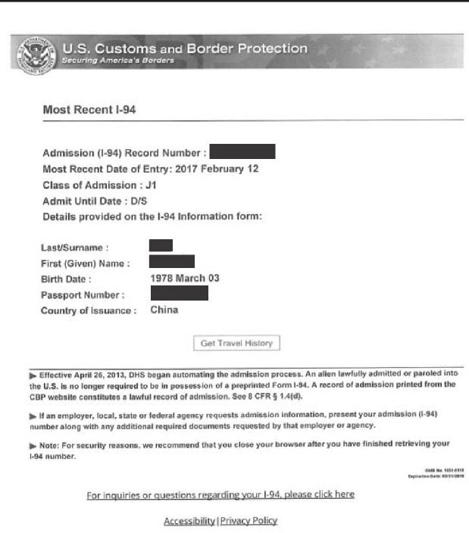

Social Security Card
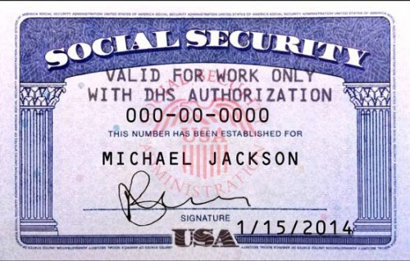

Form I-20 (F-1 visa)
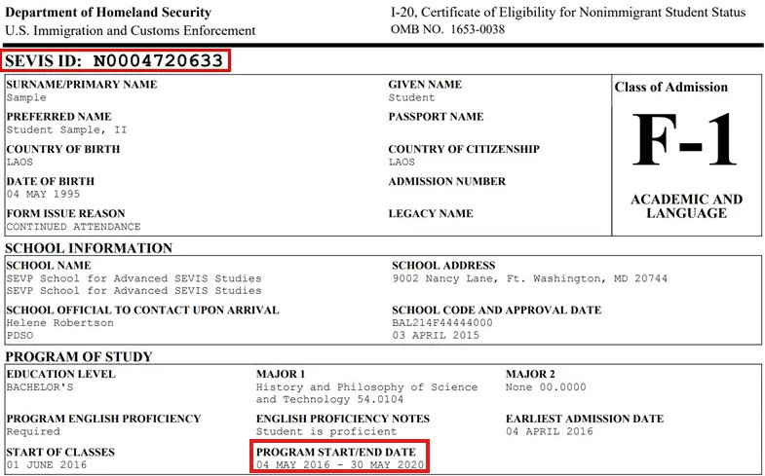

DS-2019 (J-1 visa)
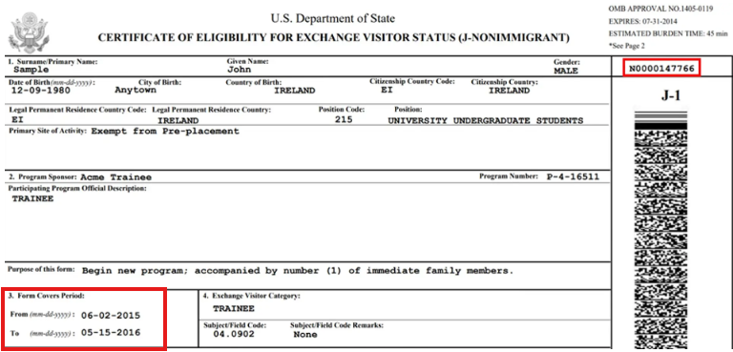
Employment Authorization Document (EAD Card/I-766)
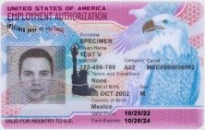

I-797A Approval Notice (H-1B)
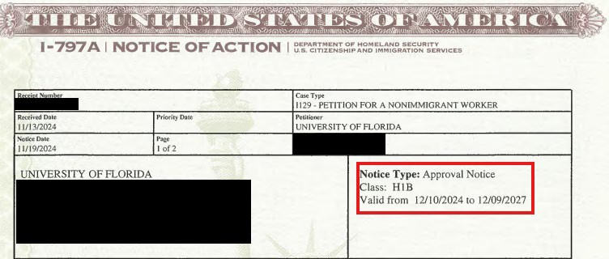

REVERIFICATIONS

Process and Guidelines
Reverification of employment authorization is required for foreign national employees whose work authorization documents have expired or are nearing expiration. This process ensures that all employees maintain valid authorization to work in the United States.
Temporary work authorization can be monitored via the Visa Expiration Report:
- Enterprise Analytics > Access Enterprise Analytics> Team Content > Human Resources Information > Workforce Information > Visa Status Expiration Report by Department

Steps to Reverify
- Meet with employee and review documentation
  - An employee’s employment authorization must be reverified no later than the date their current work authorization expires.
- Employee reviews list of Acceptable Documents and presents any List A or C document showing current employment authorization
  - Document must be valid if work authorization has expiration date
- Employer reviews documents to verify accuracy and authenticity
- Employer completes Supplement B (formerly Section 3) on Form I-9 (pg. 4)
- Submit Form I-9 and supporting document(s) via the I-9 Reverification Portal
  - Cases with incomplete I-9 forms and/or missing work authorization may be denied
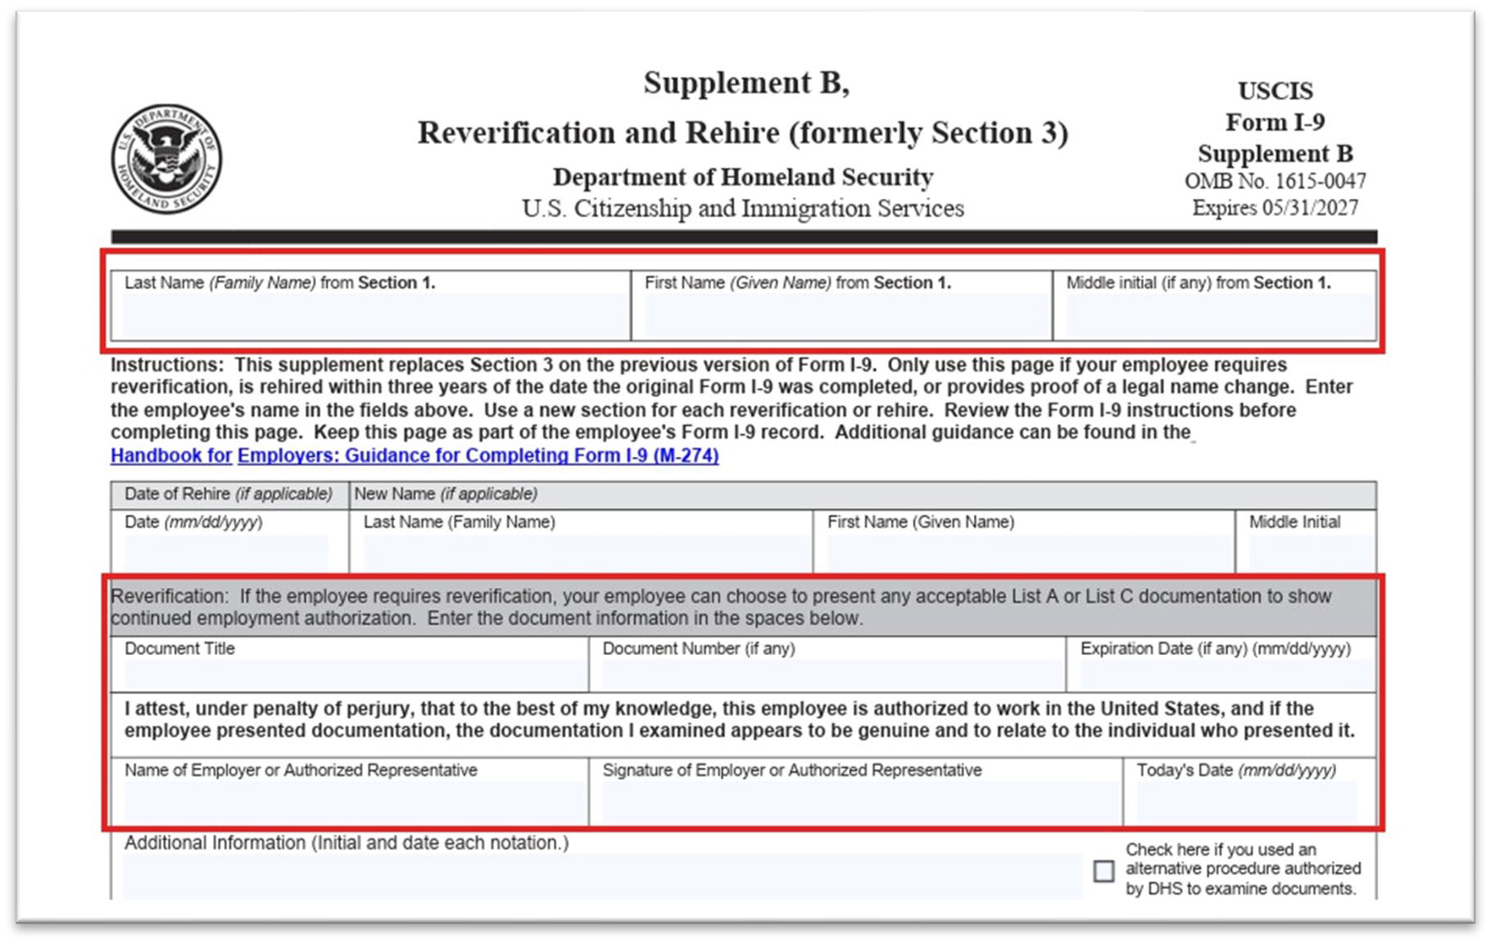

Key Reminders

- Accurate personal details: Ensure all employee details like full name, middle initial, and last name are entered correctly.
- Correct dates: Double-check the date of rehire, the date of reverification (today’s date), and the expiration date of the presented document.
- Document details: If you reverify employment eligibility, accurately record the document title and document number used.
- Signature and date: Always sign and date the Supplement B section in the designated area.
- Name changes: If an employee has legally changed their name, update the information on Supplement B accordingly.

Reverification is Not Required
- U.S. Citizens and Noncitizen Nationals: Individuals in these categories do not require reverification, regardless of document expiration.
- Permanent Residents: Current holders of Form I-551 (Green Card) do not need reverification upon document expiration.

Reverification is Required
Foreign Nationals with Expiring Work Authorization: Non-resident and resident aliens whose employment authorization documents (e.g., Form I-20, DS-2019, H1-B and EAD) are approaching expiration and need to undergo reverification.

Common Case Types
  - Change of status: approval notice (most are already employed here, going from F-1 to H-1B)
  - Extension:
    - Approval Notice, OR;
    - Prior Approval Notice with timely filed Receipt Notice (check that received date is prior to original expiration date). You add 240 days to expiration date of prior Approval Notice.

Form I-20 (F1)
  - Form Issue reason should say Continued Attendance or Change of Education Level
- Initial Attendance and Transfer Pending are not accepted for reverification purposes
  - Need a new I-20 with new program start/end dates (on page 1)
  - Need a new I-20 with new CPT dates (found on page 2)

Form DS-2019 (J1/J2)
  - New DS-2019: Ensure its for UF and check “Form Covers Period” dates
  - J2 VISA Holders: Do not get an automatic extension

I-767A Approval Notice (H-1B)
Timely process (reverify) the extension (Receipt Notice) prior to receiving the Approval Notice, as the Approval Notice will adjudicate the Receipt Notice.

STEM OPT (EAD)
  - STEM OPT (not OPT)
3. EAD category C03B to C03C – EAD card with category C03B and USCIS receipt notice with category C03C gets automatic 180-day extension as long as the received date on receipt notice is dated before the EAD card expires
  - A12 or C19 (Temporary Protected Status)
    - https://www.uscis.gov/humanitarian/temporary-protected-status

Approval Notice

Notices are not valid for Employment Authorization because the automatic extension ceases once USCIS adjudicates your STEM OPT extension application. A new EAD card is required.
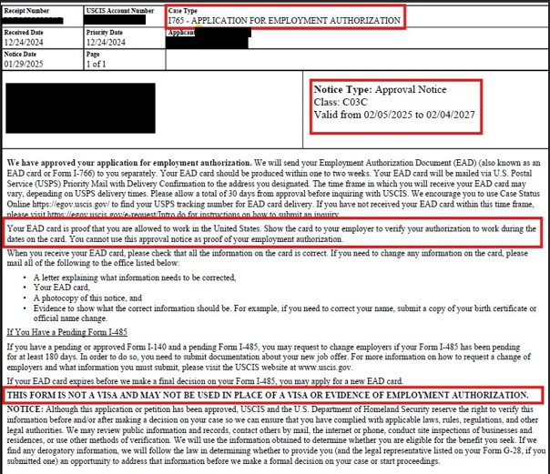

Receipt Notice
If you filed Form I-765, Application for Employment Authorization, to renew your expiring Employment Authorization Document (EAD), you may qualify for an up to 540-day automatic extension of the expiration date printed on your EAD while your application is pending. You qualify for this automatic extension if:
  - The Form I-797C, Notice of Action, receipt notice you received for your pending Form I-765 renewal application has a “Received Date” that is before the “Card Expires” date shown on the face of your EAD;
  - Your renewal application is under a Eligible Category/Class for an automatic extension; and
  - The category on your current EAD matches the eligibility category/class listed on your Form I- 797C, Notice of Action, receipt notice.
  - Your EAD renewal application is still pending with USCIS when your current EAD expires.
If all the above factors are true, then your employment authorization or EAD, or both, are automatically extended for up to 540 days while your EAD renewal application is pending. To determine your auto-extended EAD expiration date, please see the Automatic Extension Eligibility Calculator.
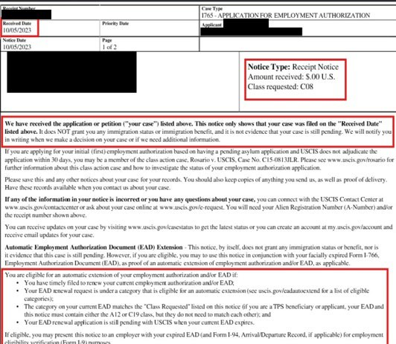

E-VERIFY

Overview
E-Verify is an online system that checks a new hire Form I-9 against DHS and SSA records to confirm work authorization. Federal contractors, including universities with E-Verify contract requirements, must verify all new and existing employees working on federal contracts.

E-Verify cases may be submitted one of two ways: 1) Navigating to a completed GatorStart packet and selecting “Complete I-9” or 2) Navigating to I-9 Management and searching by employee.

Process
- Department creates an ePAF, generating a GatorStart packet
- Employee completes Form I-9 within GatorStart
- Department verifies documents and completes Section 2
- Department submits the E-Verify case in I-9 Management

Note: Breaks in service will require a new E-Verify case to be submitted in I-9 Management. Also, employees on short work break, leave of absence, or transferring from one department to another do not have to be verified again unless they have temporary work authorization, and their expiration date is imminent; see section for reverifications above.

E-Verify Case Statuses
Once the hiring department completes Section 2, E-Verify will return a status that may indicate next steps for Employment Operations & Records. Departments should not proceed with closing out the following statuses as these will be managed by UFHR.

Case Status | Definition
Employment Authorized | Majority of cases are returned as this status and closed out automatically
Photo Matching | Occurs if the U.S. passport/passport card, EAD card, or permanent resident card is used; departments must attach a copy of one of these documents if used for Section 2
Unconfirmed Data | Possible mismatch between information on Form I-9 and DHS and/or SSA database
Error – Request Help | Missing or having incorrect information such as UF TempID was used in lieu of SSN
Pending Referral | Information did not match records available to  DHS and/or SSA; additional action is required on the employee (UFHR will facilitate)

Steps to Prevent Error- Request Help
Most Common Issue: Employees using the UF TempID instead of the Social Security Number and the case is submitted with the temporary number instead of removing the SSN and selecting “SSN Applied For” directly underneath.
- Click on Review/Change Section 1 Information link in I-9 Management

- Delete UF TempID in the SSN Field
- Select “SSN Applied For” box directly underneath
- Proceed to complete Section 2
Important: Remember to return to I-9 Management in order to update and submit the E-Verify case once the employee provides their social security number after receiving their card from the Social Security Administration (SSA).
- To update SSN and submit E-Verify case, login to I-9 Management > Search for Employees > Enter their name and search > Select employee’s name > Select Change SSN > Edit SSN > Continue

UF Temporary IDs
A UF TempID is a temporary ID number that the University of Florida (UF) issues to foreign nationals who do not yet have a Social Security Number (SSN). The UF TempID is used to log into GatorStart and expedite the hiring process.
- Section 2 cannot be submitted without the SSN in Section 1 of Form I-9. For employees who have a UF Temporary ID, the department must select the “Applied For SSN” option which will place their case in a queue; the message “I-9 is not eligible for E-Verify, missing some Section 1 data” will appear.
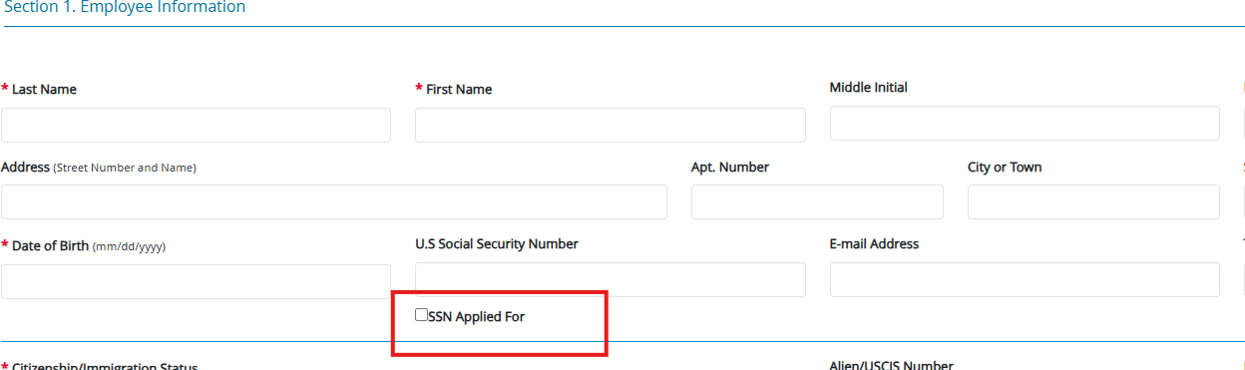

Departments may monitor employees with a UF Temporary ID via:
Enterprise Analytics > Human Resources Information > Employees with Temporary SSNs

Pending Referral Cases
- Occasionally cases will go into a pending referral/tentative non-confirmation, which may require the employee to contact the appropriate agency: DHS or SSA
- If E-Verify case is in this status, Employment Operations & Records (EOR) will review and contact both the employee and department if action is needed
- Employee should abstain from contacting any outside agencies until speaking with EOR
- During this time, employee may continue to work until their case has been resolved

CONTACTS
The following departments are routinely involved in the various aspects of these topics and may provide additional guidance.

Employment Operations & Records
- Topics: Form I-9 and E-Verify
- Email: ufhr-employment@ufl.edu

Payroll Services
- Topics: Foreign National Information System (FNIS) and tax information and guidelines
- Email: Payroll-services@ufl.edu

UF International Center
- Topics: Visa Information for F-1 Students and J-1 Student/Scholars
- Contact page: https://internationalcenter.ufl.edu/about-ufic/staff

Immigration Compliance Services
- Topics: H-1B, TN, O-1, E-3 immigration statuses
- Email: HRSImmigrationComplianceServices@mail.ufl.edu

RESOURCES
USCIS I-9 Central
USCIS Employer Handbook
E-Verify Frequently Asked Questions
E-Verify Employee Rights and Responsibilities
UF International Center (for F-1 and J-1 students/scholar visas) Immigration Compliance Services (for H-1B, TN, O-1, E-3 visa holders) Foreign National FAQs
What Can Hiring Departments Do in GatorStart?

