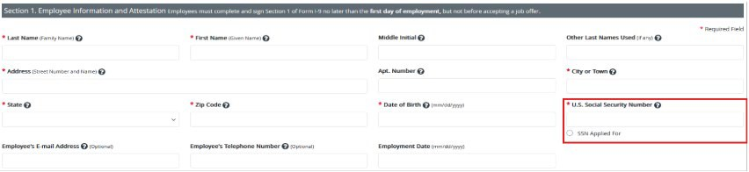
UF Temporary IDs
A UF TempID is a temporary ID number that the University of Florida (UF) issues to foreign nationals who do not yet have a Social Security Number (SSN). The UF TempID is used to log into GatorStart and expedite the hiring process.
- For employees who have a UF Temporary ID, the department must follow these steps before submitting Section 2:
  - Click on Review/Change Section 1 Information link in I-9 Management
  - Delete UF TempID in the SSN Field
  - Select “SSN Applied For” box directly underneath
  - Proceed to complete Section 2.
  - This will place their case in a queue; the message “I-9 is not eligible for E-Verify, missing some Section 1 data” will appear.
Important: Remember to return to I-9 Management to update and submit the E-Verify case once the employee provides their social security number after receiving their card from the Social Security Administration (SSA).
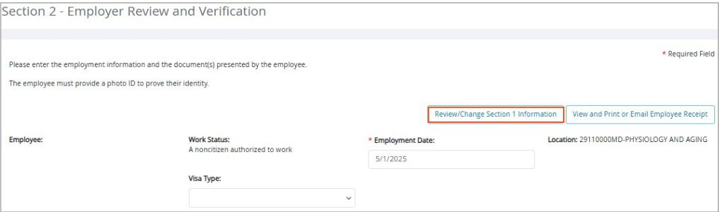
To update SSN and submit E-Verify case, login to I-9 Management > Search for Employees > Enter their name and search > Select employee’s name > Select Change SSN > Edit SSN > Continue

