

In order to work for the University of Florida, all employees must present a valid U.S. social security card. To obtain one, visit the Social Security Administration Office at least 10 calendar days after your arrival to the United States.
Failure to do so, may significantly delay your hiring process and your first paycheck.

Necessary Documents
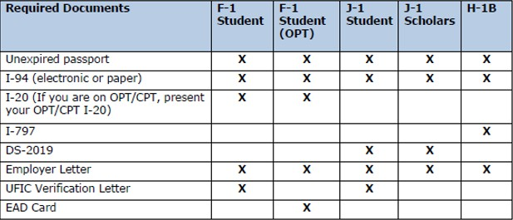

UF International Center (UFIC) Verification letter
The letter provided by the UFIC must contain the following information:
- Identifies foreign national
- Confirms foreign national’s current school status
- Identifies employer and type of work

Employer Letter
The letter provided by the employer must contain the following information:
- Foreign national’s job duties
- Employment start date
- Foreign national’s planned total work hours per week
- Supervisor’s name and phone number

Location
Social Security Administration Office (Gainesville)
- SSA Office Locator: https://www.ssa.gov/locator/
- Social Security Administration Office
- Address: 4562 NW 13th St, Gainesville, FL 32609
- Phone: (800) 772-1213
- Hours:
  - Mon, Tue, Thurs, Fri: 9:00 am – 4:00 pm
  - Wed: 9:00 am – Noon

Useful Links
F-1 Requirements for Obtaining a Social Security Number

