Adding a Volunteer When the Volunteer Does Not Have a UFID
Contents
Adding a Volunteer When the Volunteer Does Not Have a UFID 1
Navigation 1
Add a Person of Interest 1
In the Person of Interest Information Section 4
In the Volunteer Data Section 5
For Additional Assistance 6

In cases where you either do not know whether a volunteer has a UFID or not, or they do not have one, you can add the individual as a Volunteer via a Person of Interest ePAF in myUFL. To do so, follow the steps outlined below.

Navigation
myUFL: my.ufl.edu > Main Menu > Human Resources > UF Departmental Administration > ePAF Homepage

Add a Person of Interest
- Click Start a New ePAF.
- Click Add a Person of Interest.
- Enter the First Name.
- Enter the Last Name.
- Enter the Date of Birth.
- Enter the Email Address.
- Click Search.
  - If the individual does not have a UFID you will see the following message: “Your search returned no results.”
- Click the Add button.
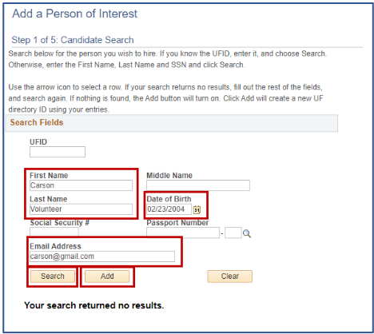
- On the first pop-up, click the OK button.
- On the second pop-up, click the Yes button.
- Enter the effective date (the date the volunteer service will begin).
- Enter the Home Address and Phone only if one is not listed.
- Enter the Business Address and Phone only if one is not listed.
- Enter the Mailing Address and Phone only if one is not listed.
- Click the Next button.
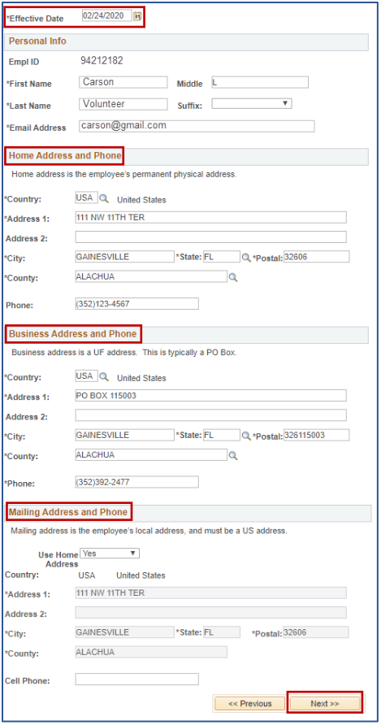

- Review and/or enter Identity Info.
  - Note: Leave the Passport Number field blank.
- Click the Save & Next>> button.
- On the pop-up, click the Yes button.
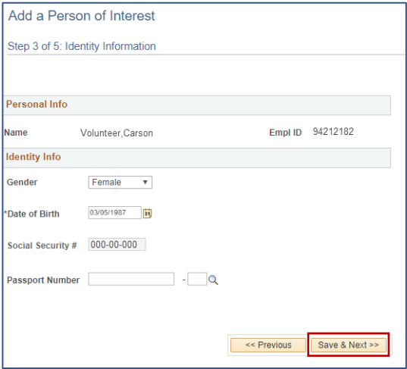
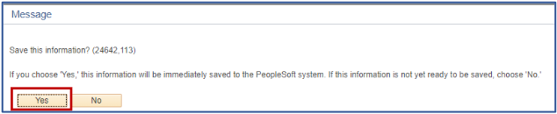

In the Person of Interest Information Section
- On the POI Type field, click the look up icon (magnifying glass).
- Select Volunteer (00014).
- In the Eff Date field, enter the date the volunteer’s service will begin.
- In the Dept ID field, enter your department ID number (you may also click the magnifying glass to look up the dept ID).
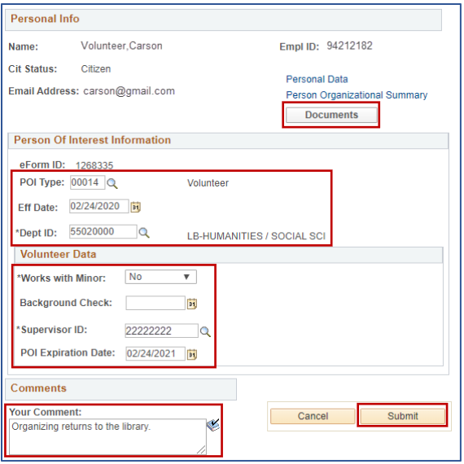

In the Volunteer Data Section
- Select Yes or No from the Works with Minors drop-down menu.
- Enter the date of the last UF Background Check, if applicable.
- Enter the UFID of the person responsible for the volunteer in the Supervisor ID field.
- Enter the end date for the volunteer service in the POI Expiration Date field, not to exceed one year. If no date is entered, the volunteer service will expire one year from the effective date.
- Enter a short description of the volunteer service in the Your Comment box.
- Click the Submit button.
- On the pop-up, click the Yes button.
Note: If the volunteer is a minor, you must upload the Parental Approval and Authorization to Treat Minors form. Click the Documents button to upload this form (See the Upload Documents Instruction Guide).

For Additional Assistance
Contact volunteer@hr.ufl.edu.

